ACG
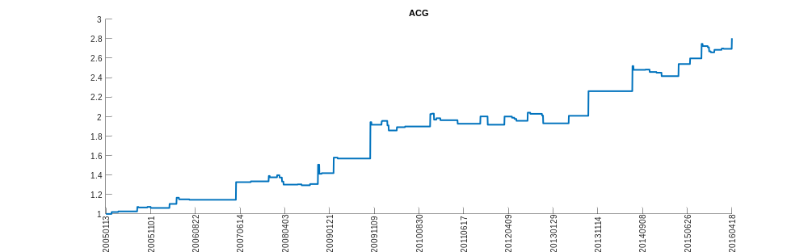
AGC
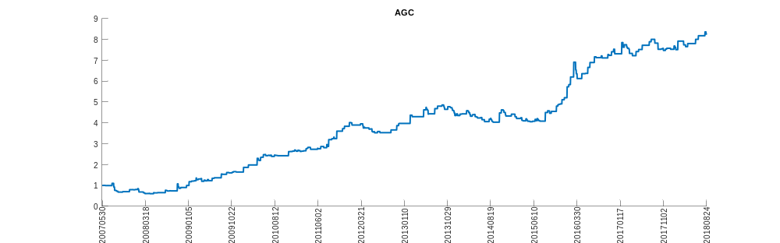
AGD
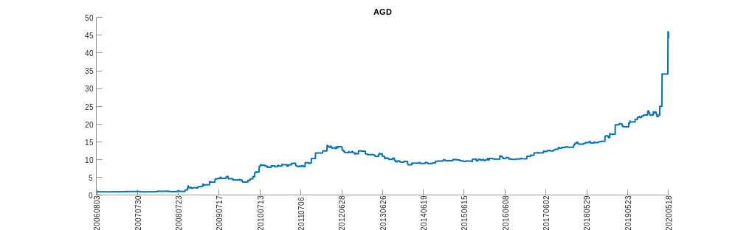
AKP
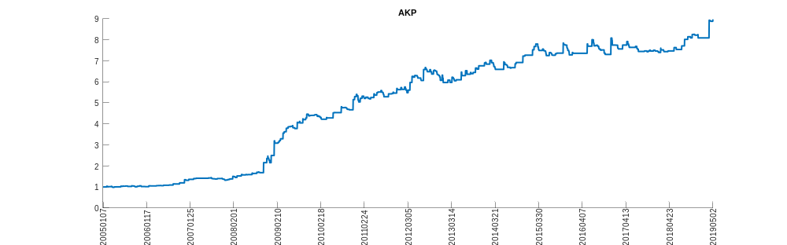
ALCSQ
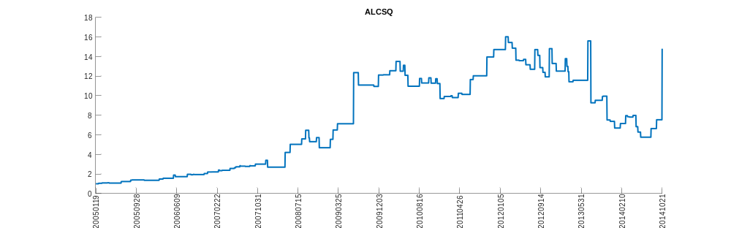
AWP
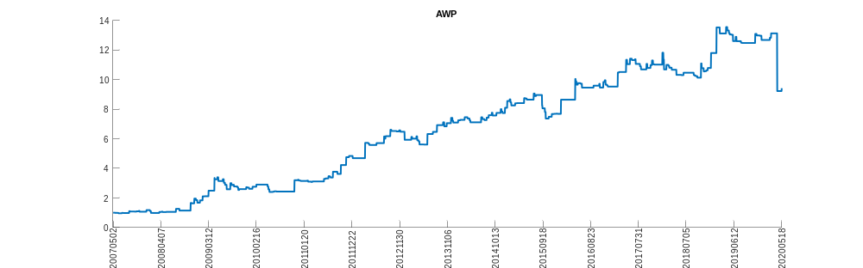
AYN
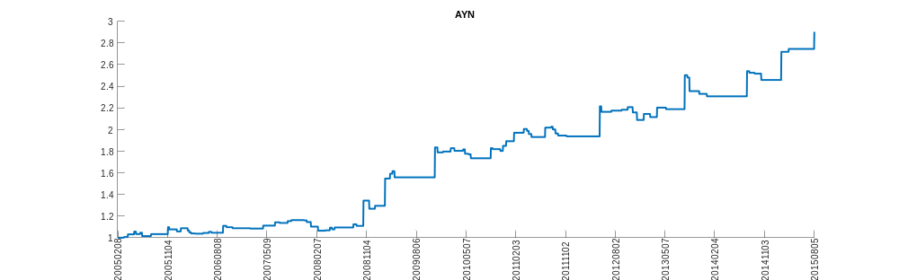
BAA
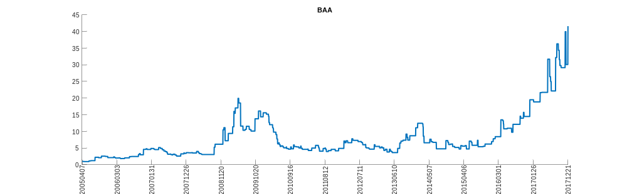
BCV
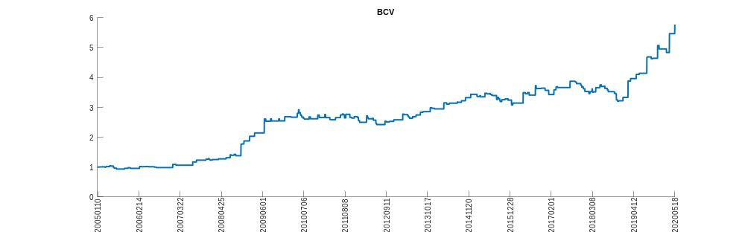
BFR
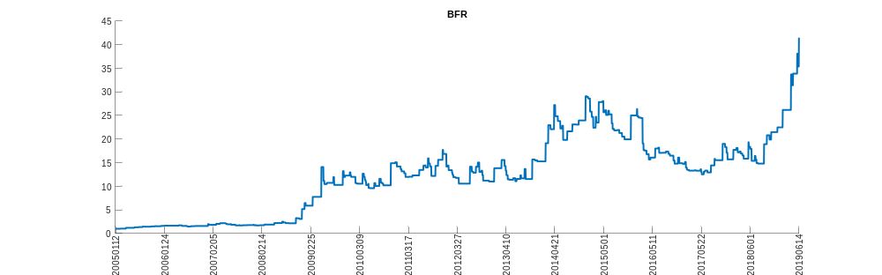
BKN
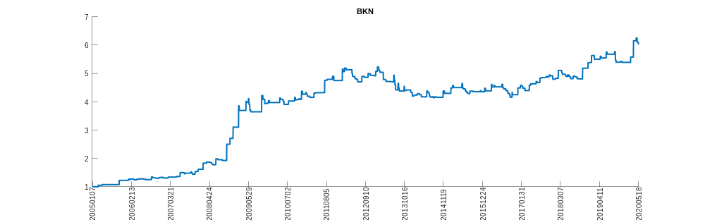
BONT
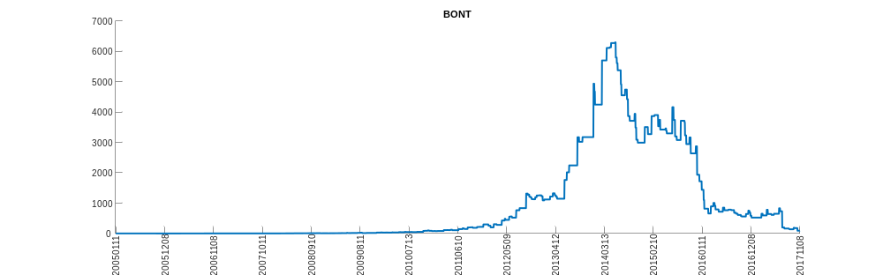
BTZ
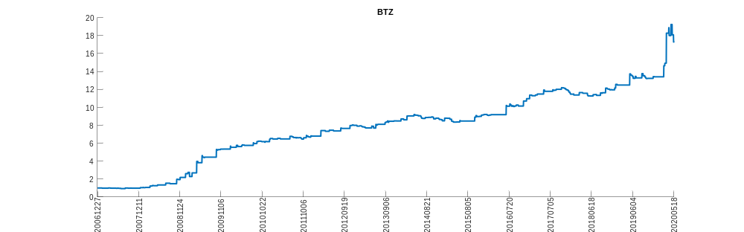
CACH
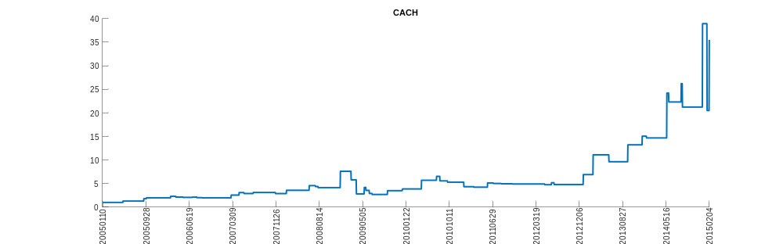
CASC
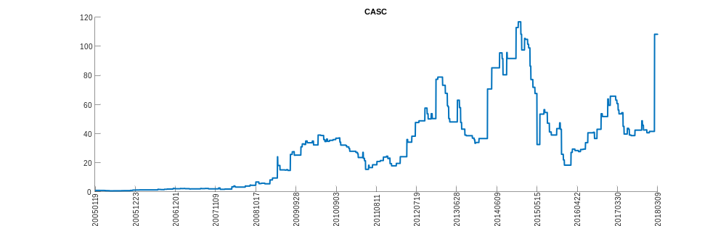
CH
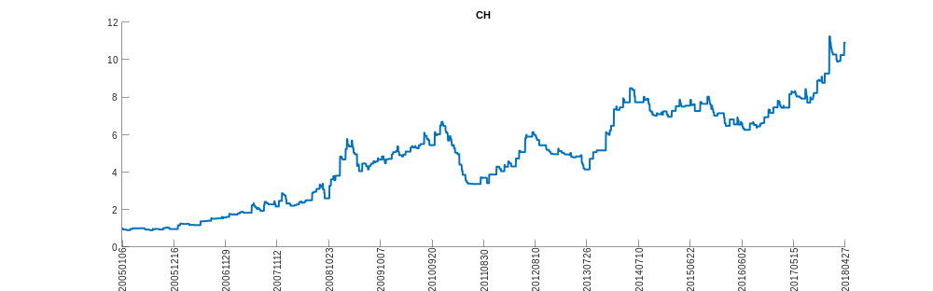
CLM
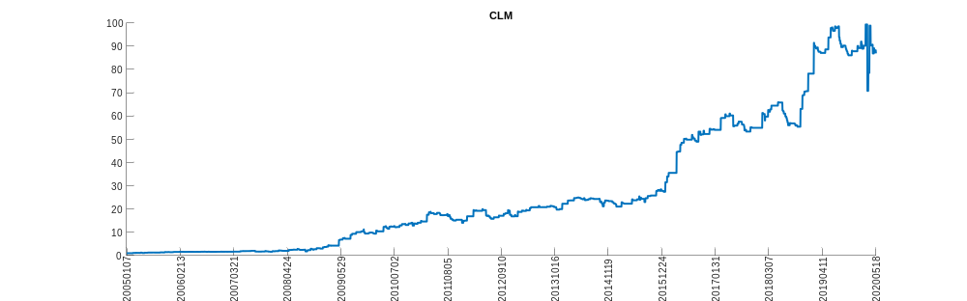
COSI
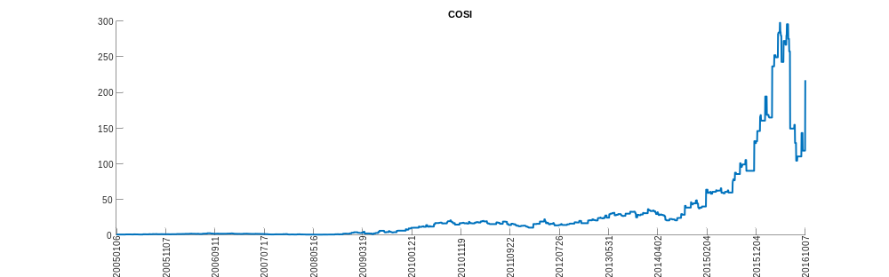
CPS
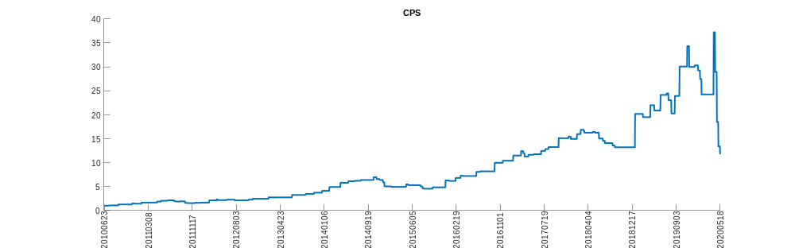
DAC
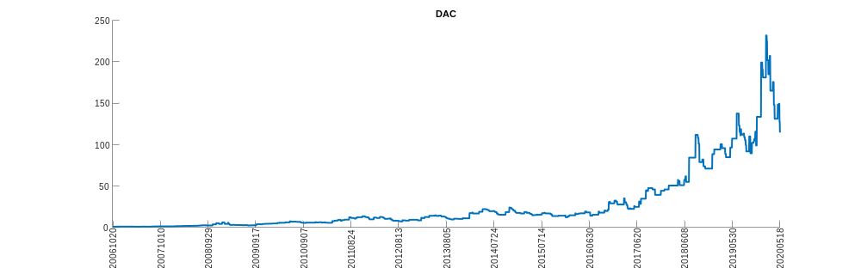
DCA
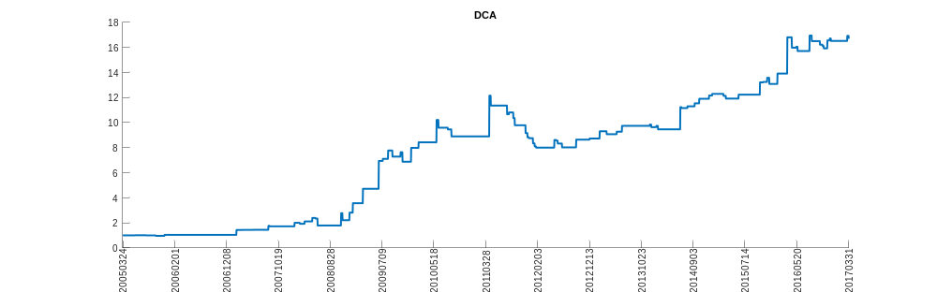
DEX
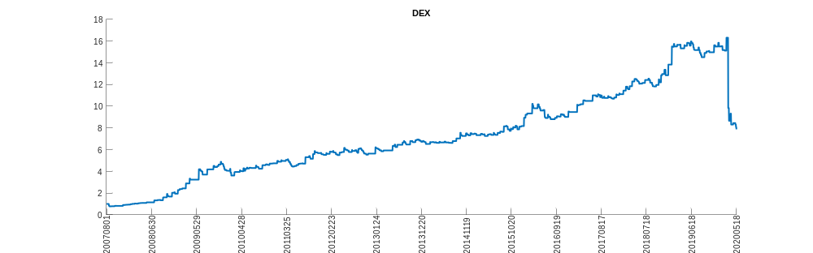
DHG
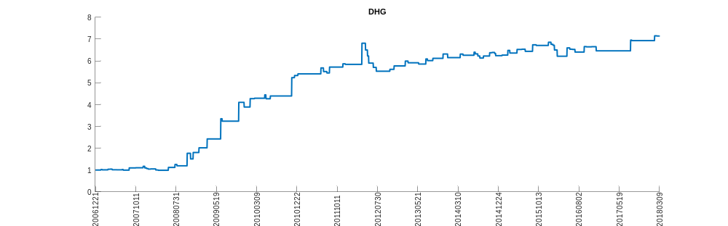
DOD
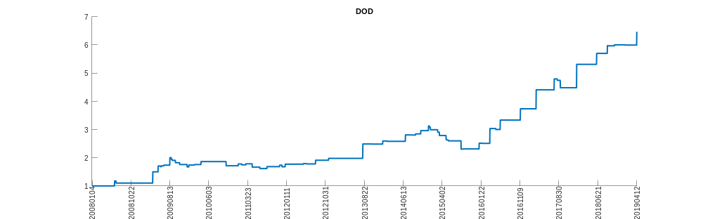
DRR
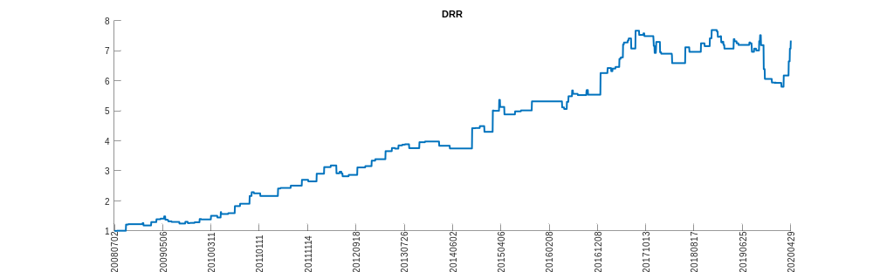
DXB
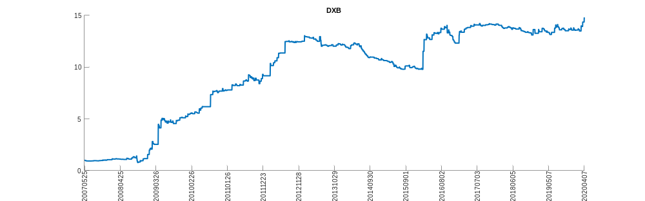
ECT
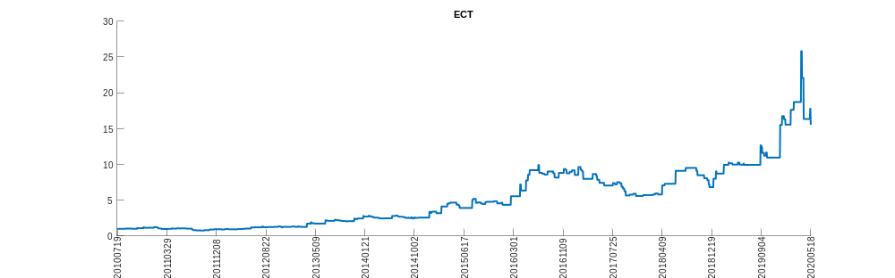
EDD
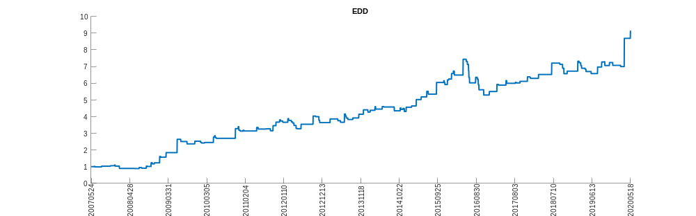
ELD
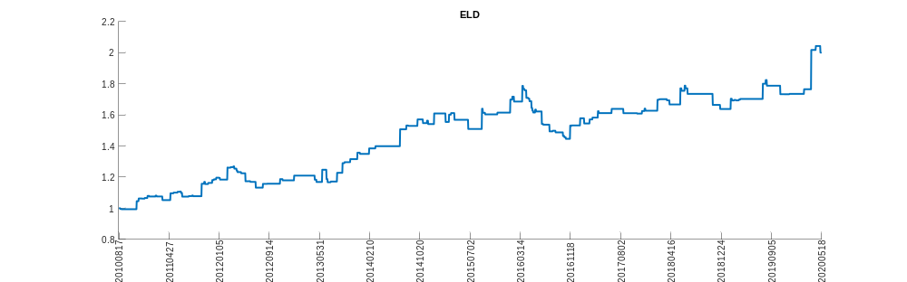
ERH
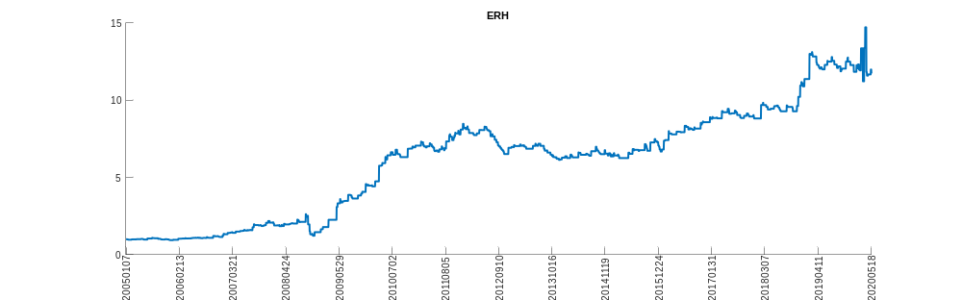
ERN
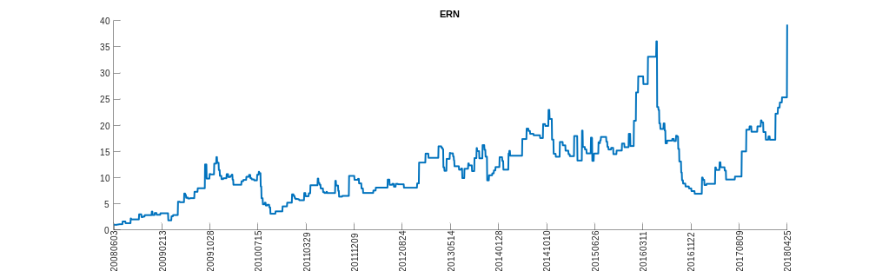
EVM
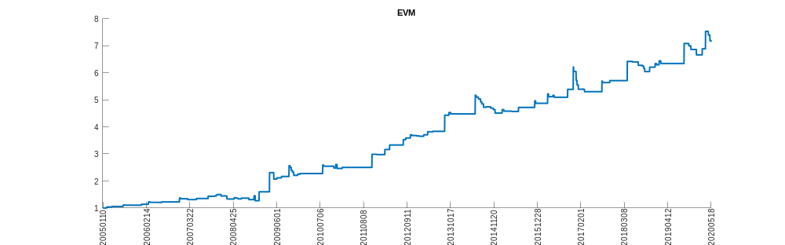
EZU
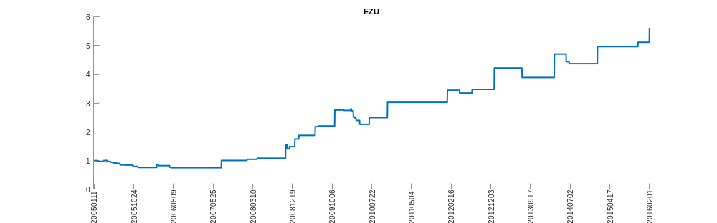
FCAU
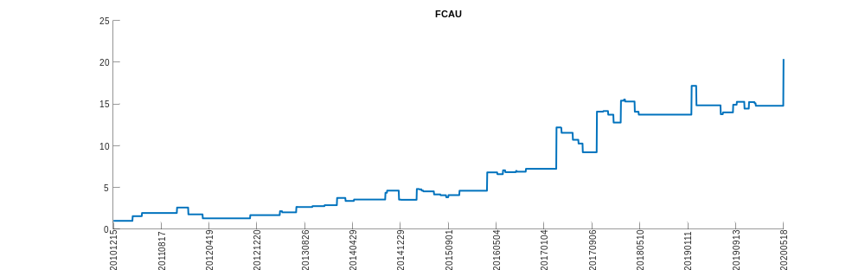
FEO
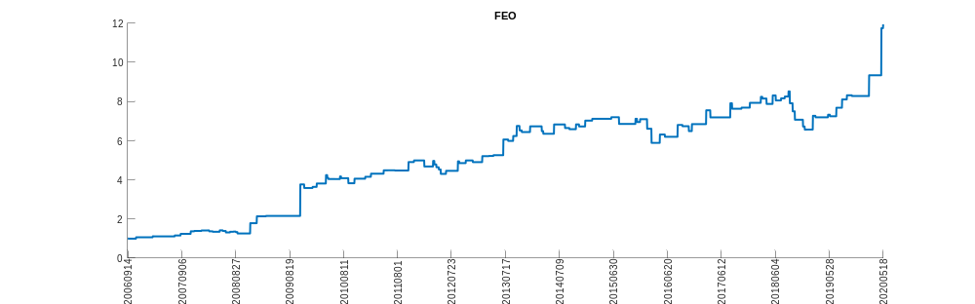
FREE
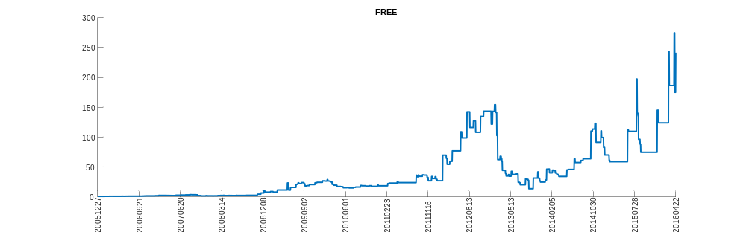
FRN
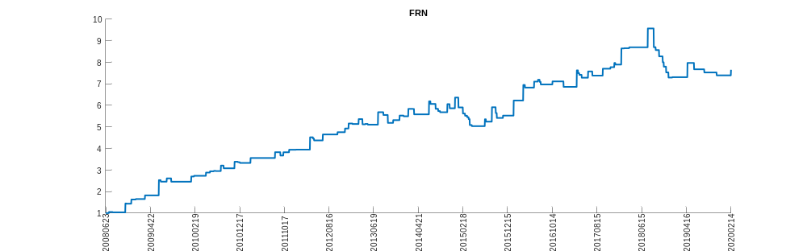
FVE
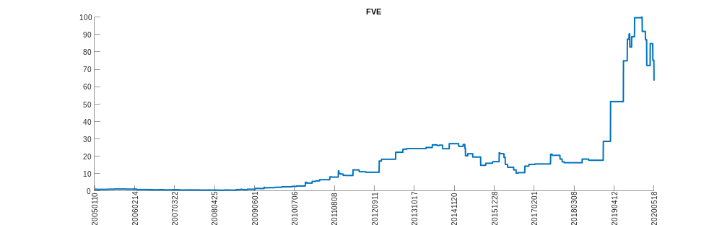
GNI
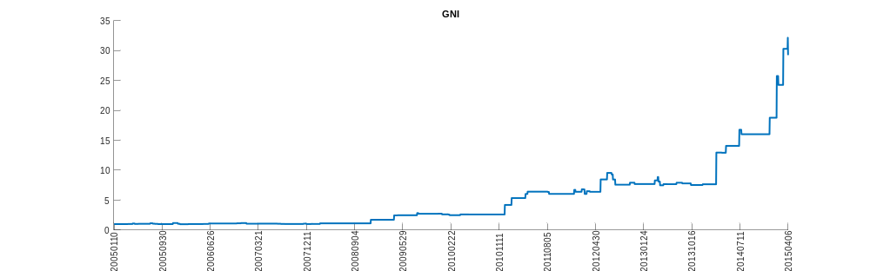
GRX
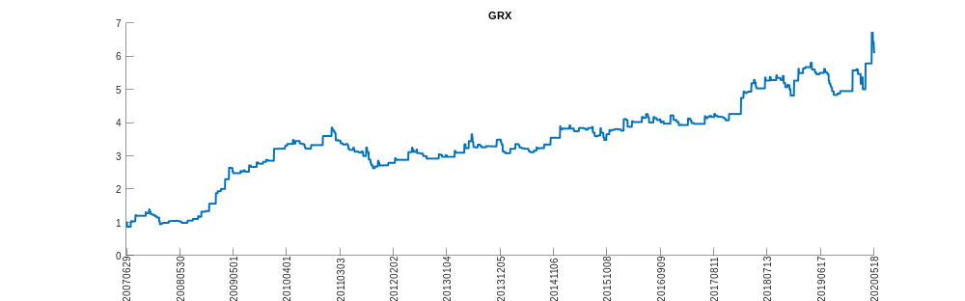
GSM
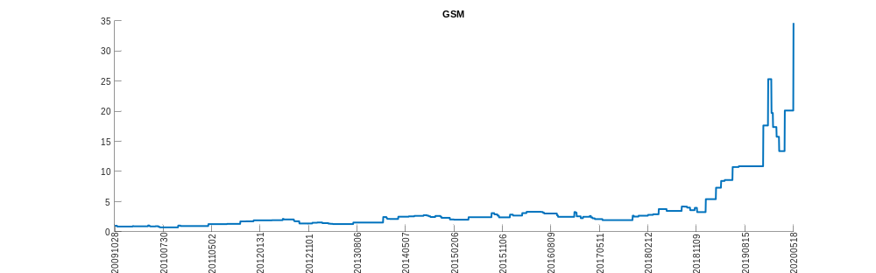
GULF
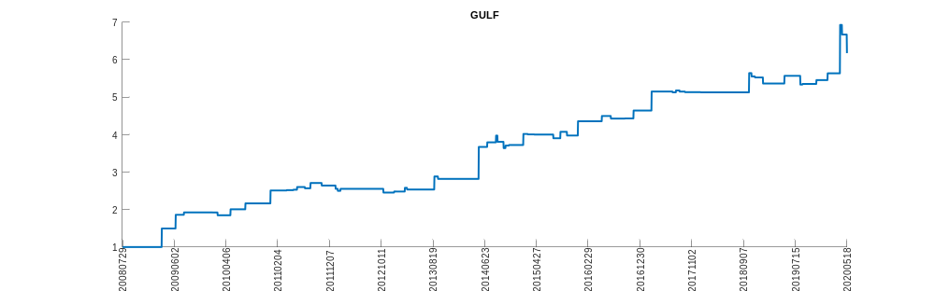
HA
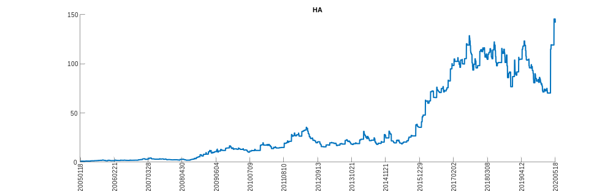
HBP
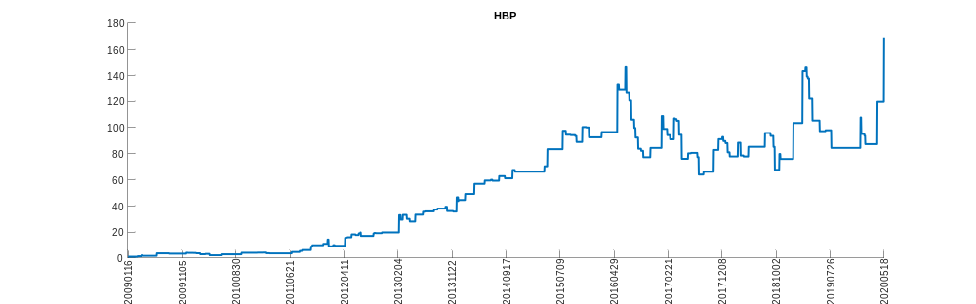
HUM
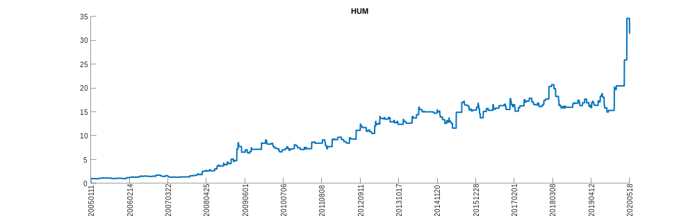
HYD
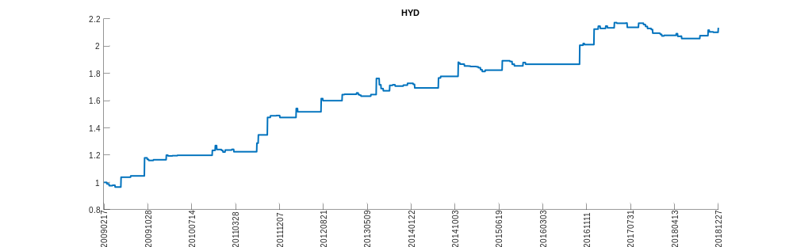
HYF
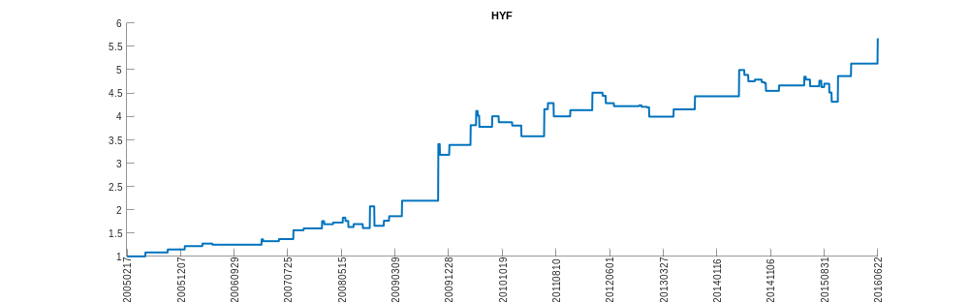
HYT
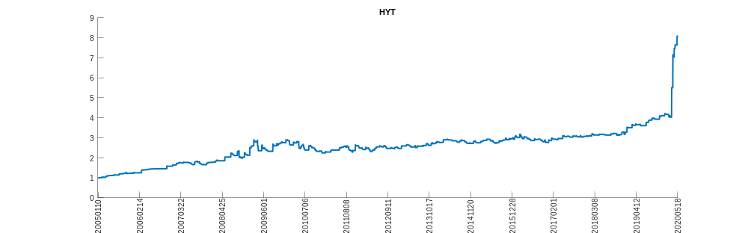
IBCP
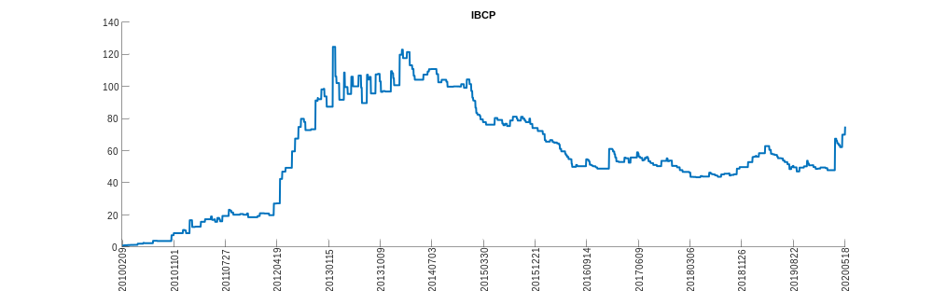
INB
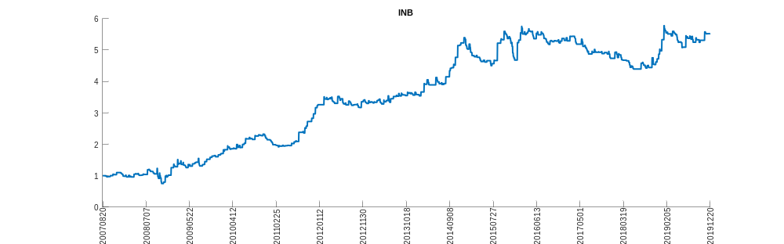
ITM
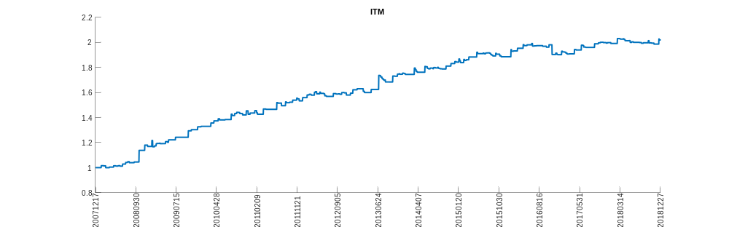
JJTFF
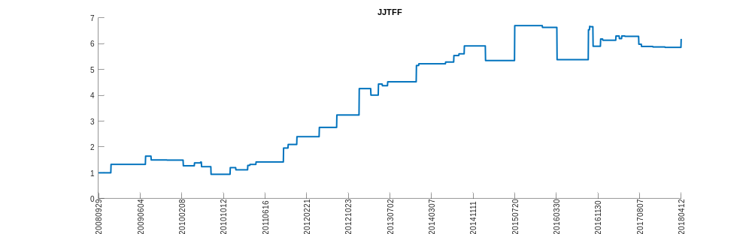
JPC
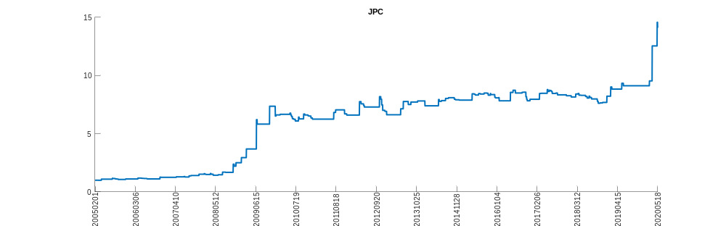
KEG
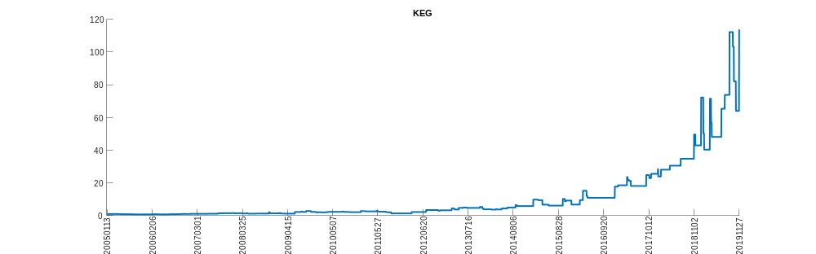
KEGX
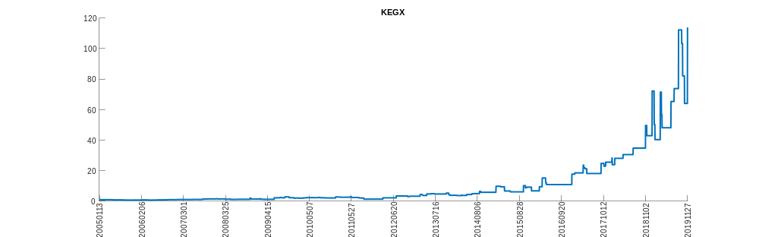
KEGXD
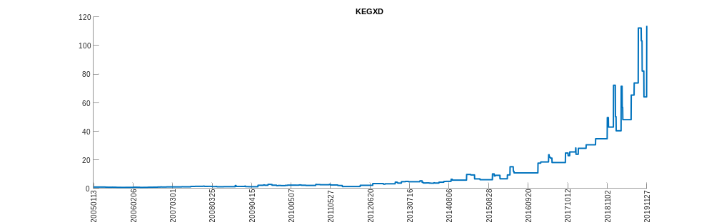
LIN_
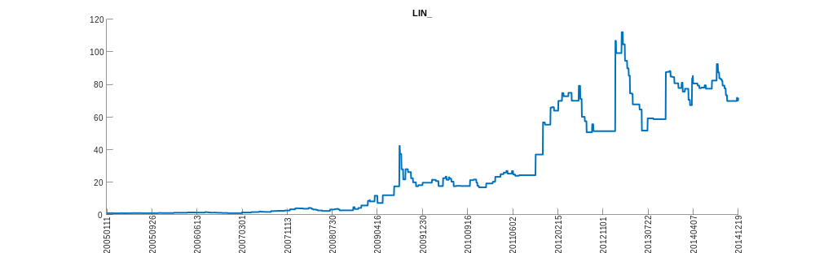
MFD
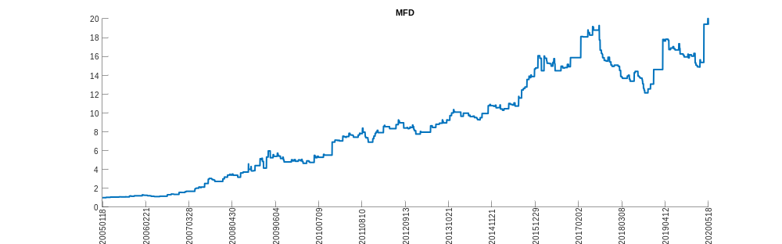
MINT
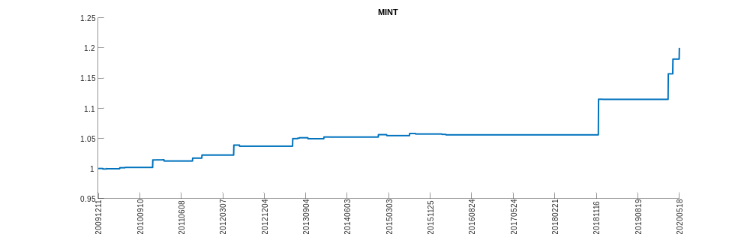
MIY
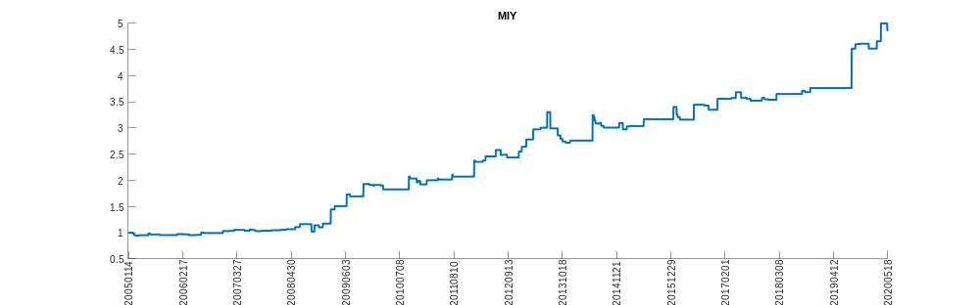
MJI
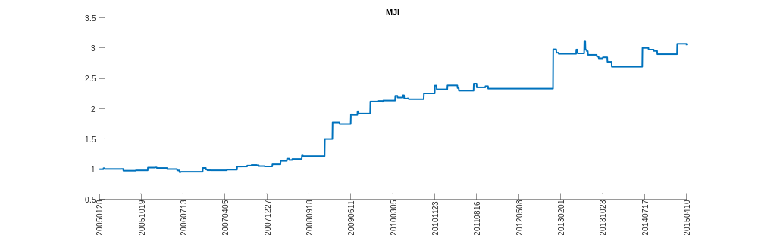
MLN
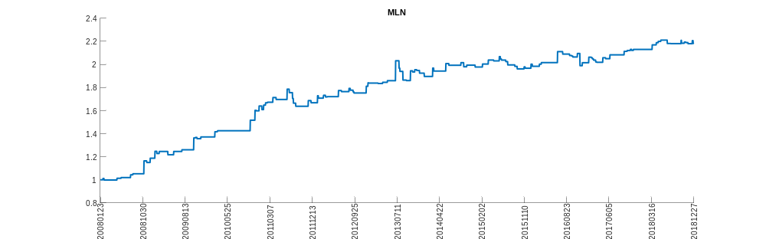
MNKD
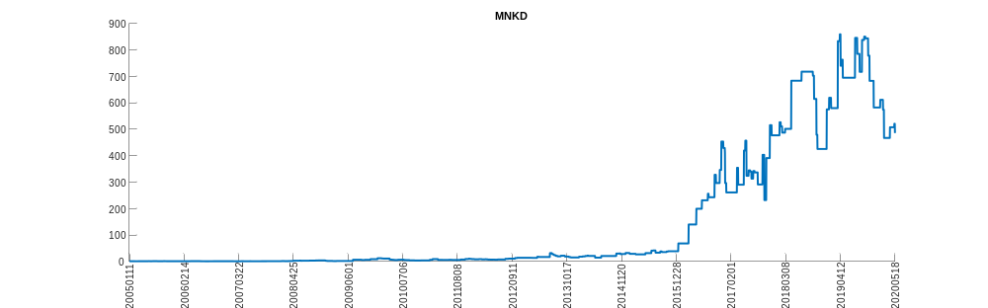
MWO
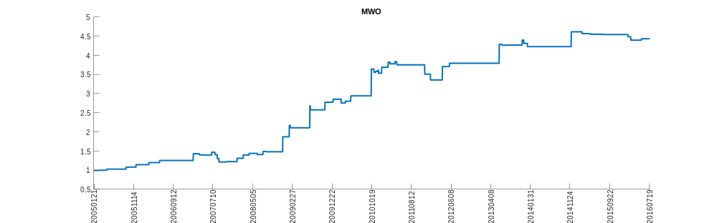
NAVB
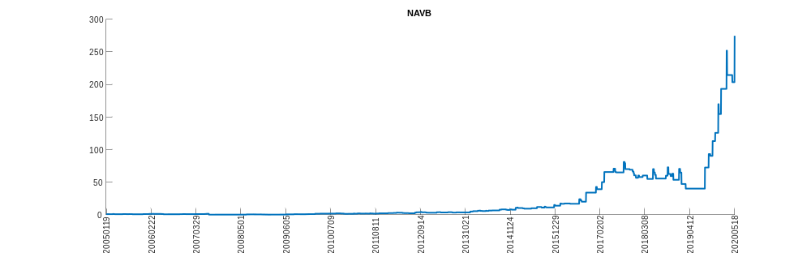
NHS
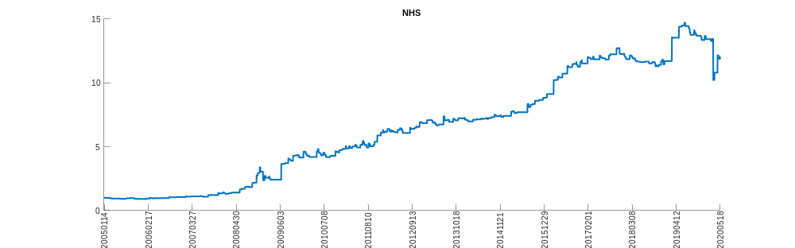
NNJ
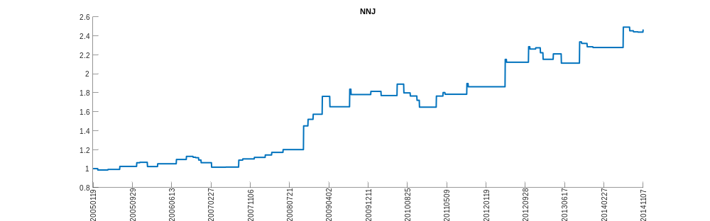
NUM
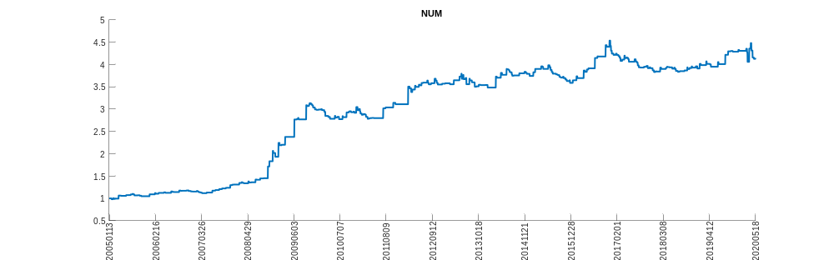
OBE
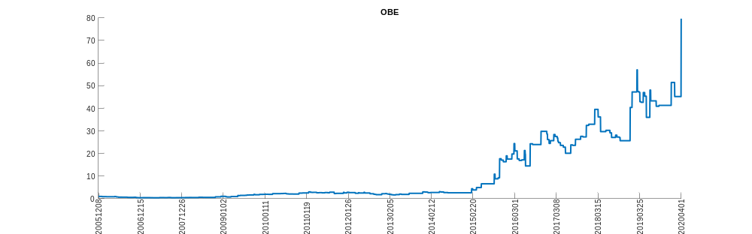
OIH
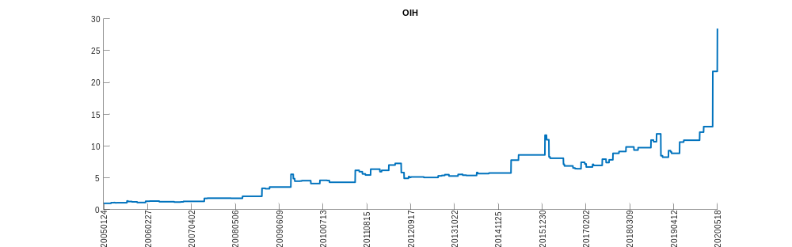
OUBS
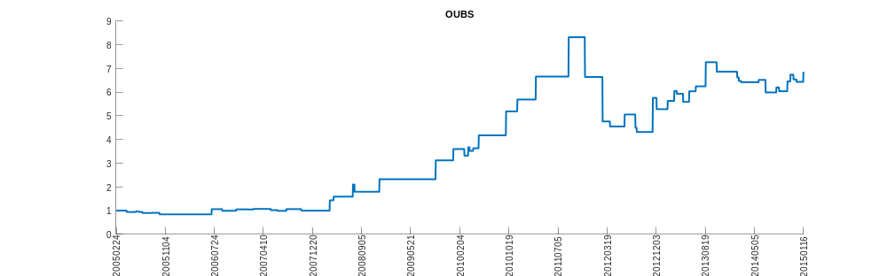
PALL
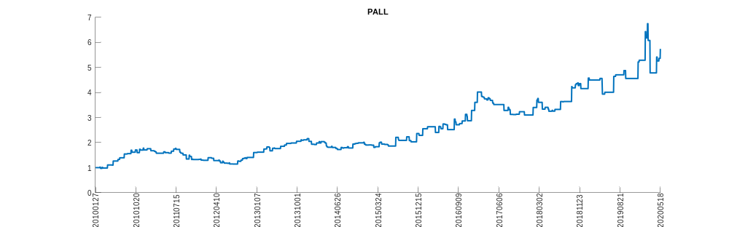
PCYC
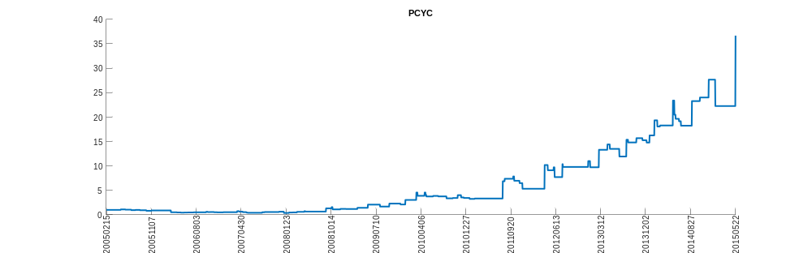
PFIE
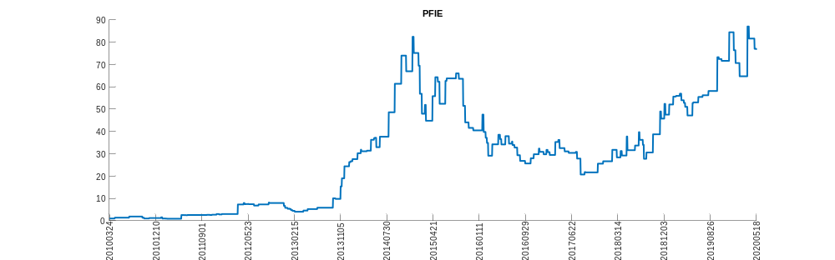
PGX
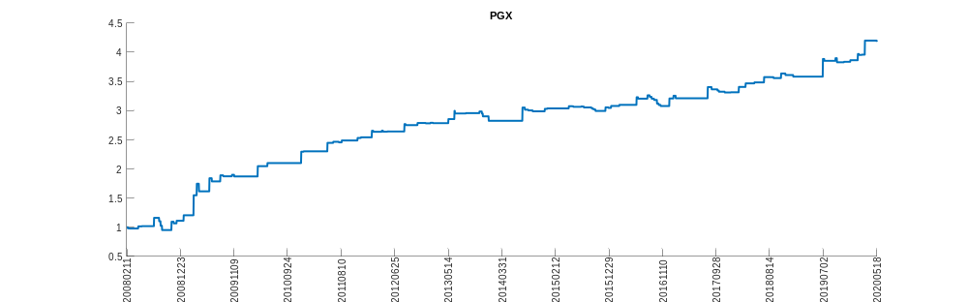
PHF
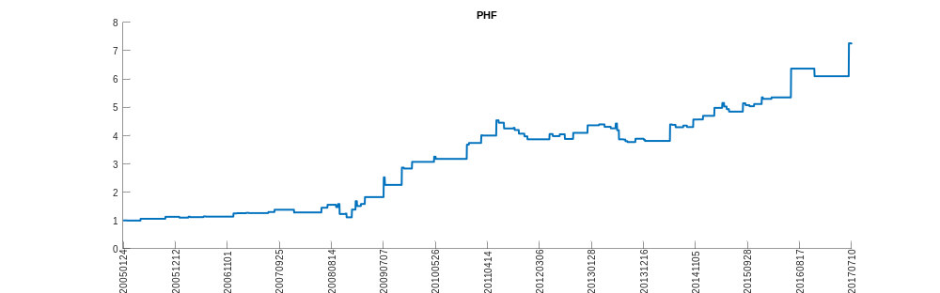
PHI
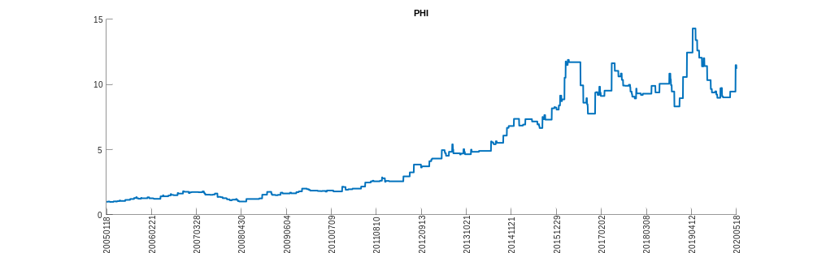
PMF
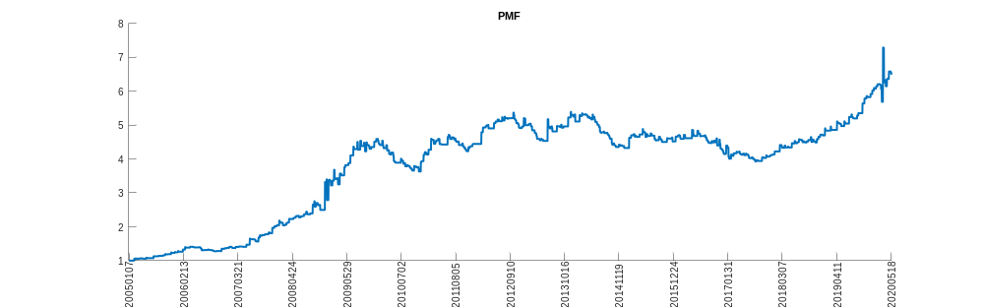
PPLT
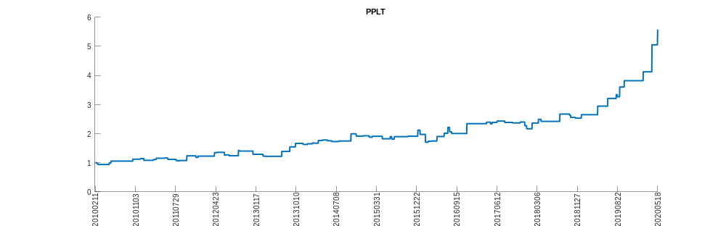
PWZ
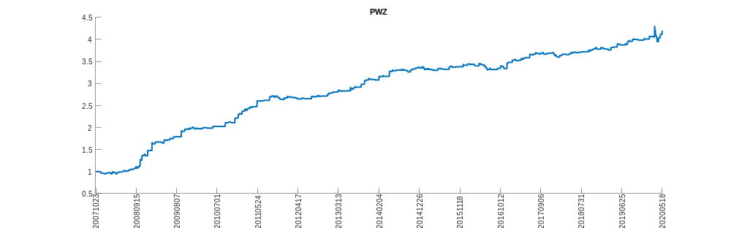
PZA
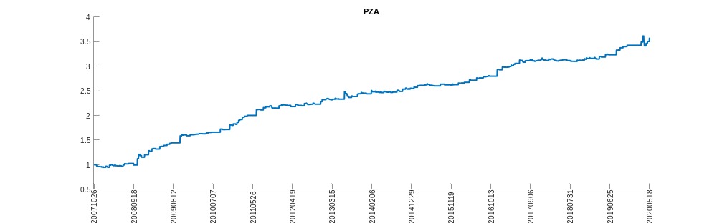
PZT
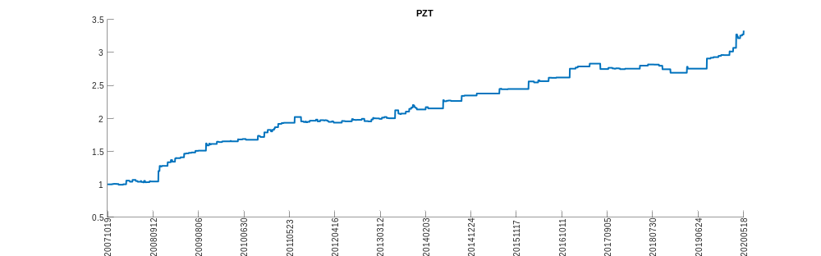
RIF
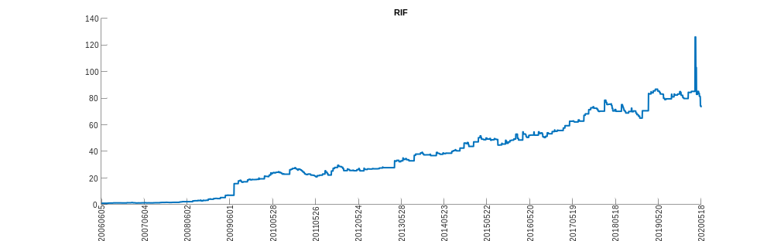
RIT
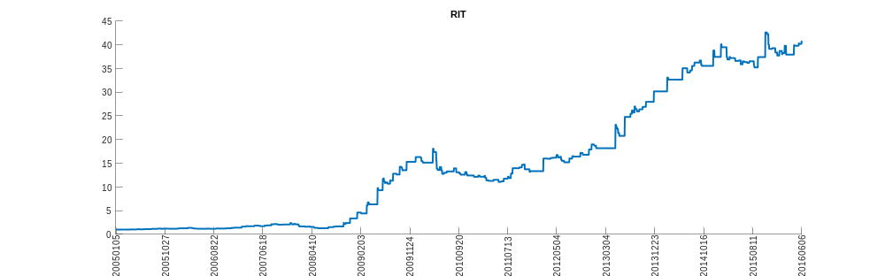
RNP
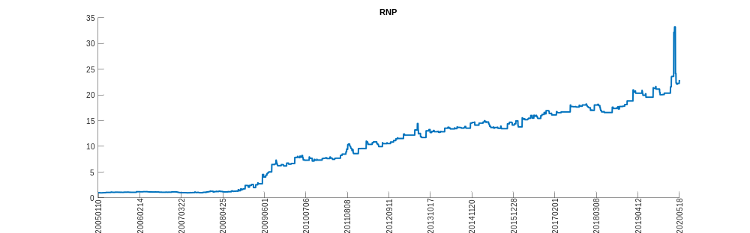
RVT
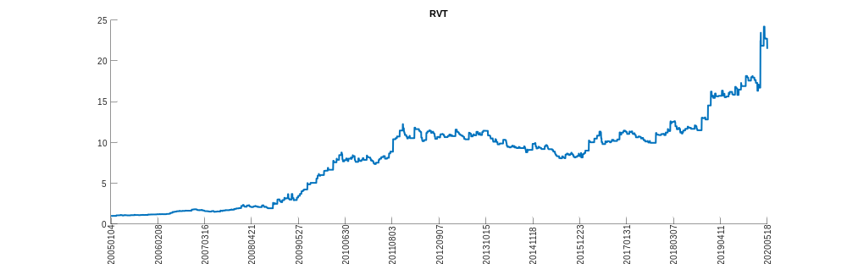
SIL
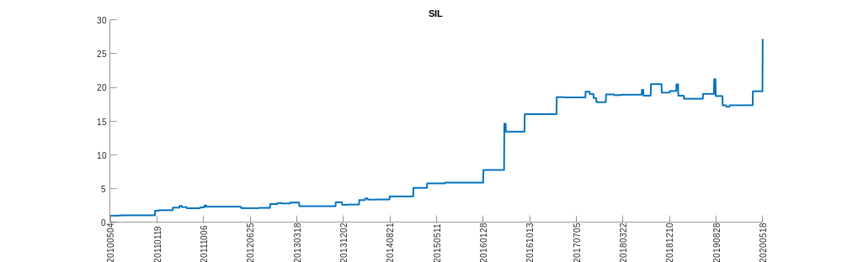
SMB
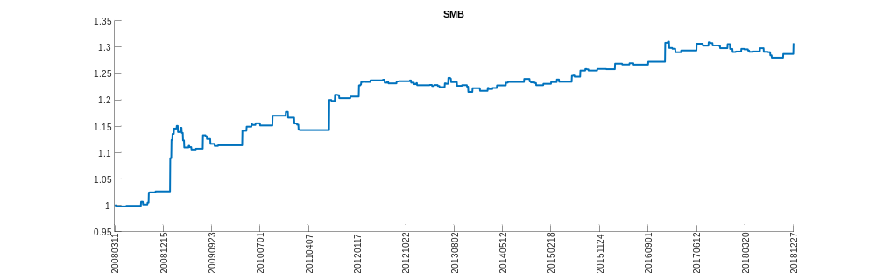
TCAP
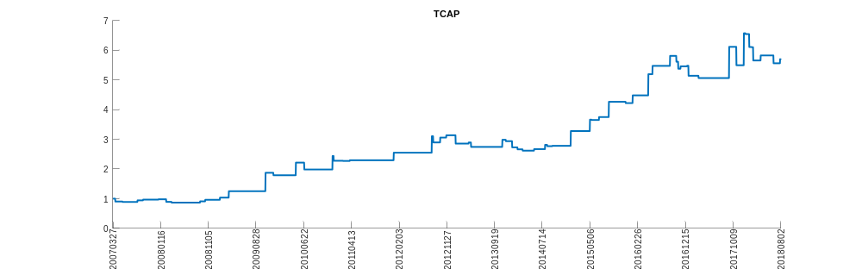
THD
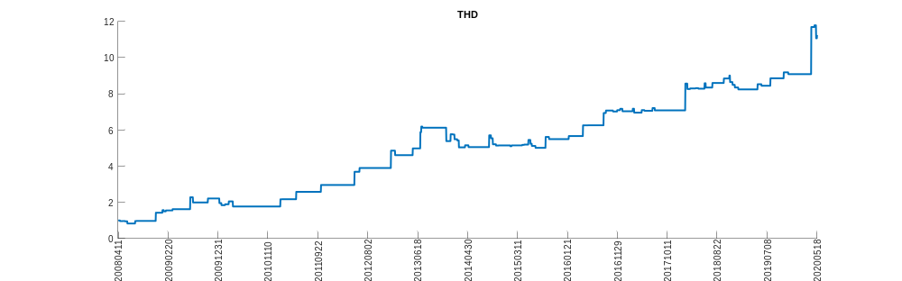
TLI
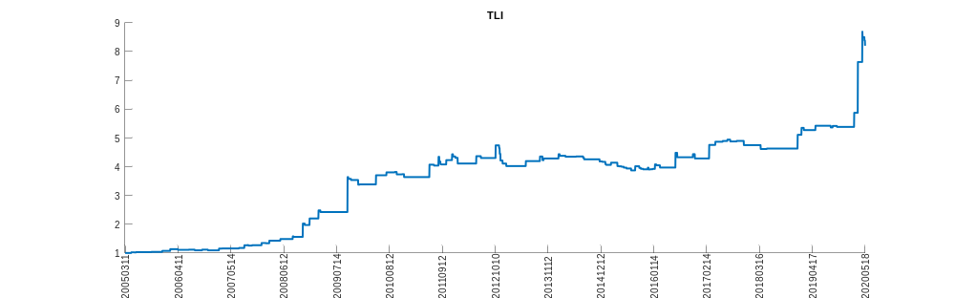
TSBK
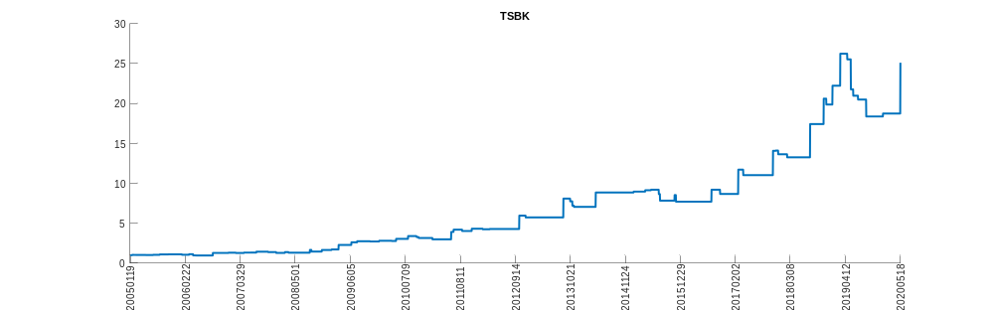
TTF
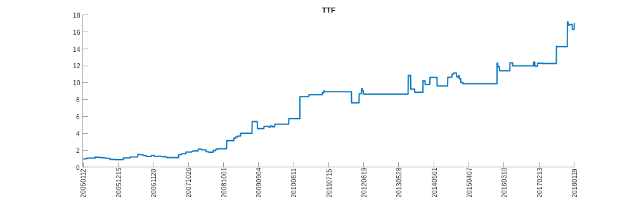
UBC
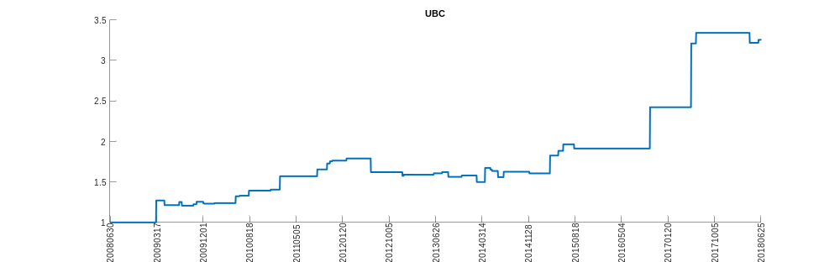
URS
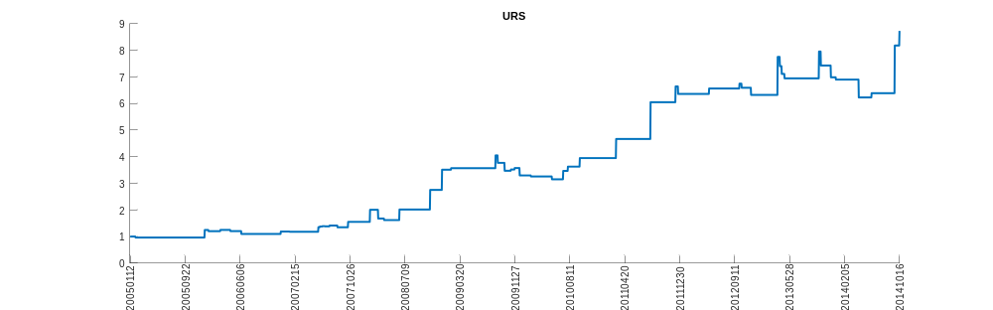
USIG
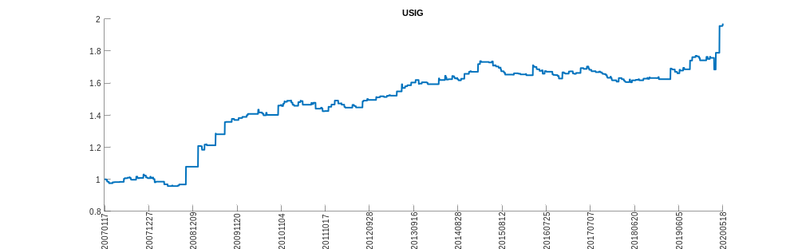
VCSH
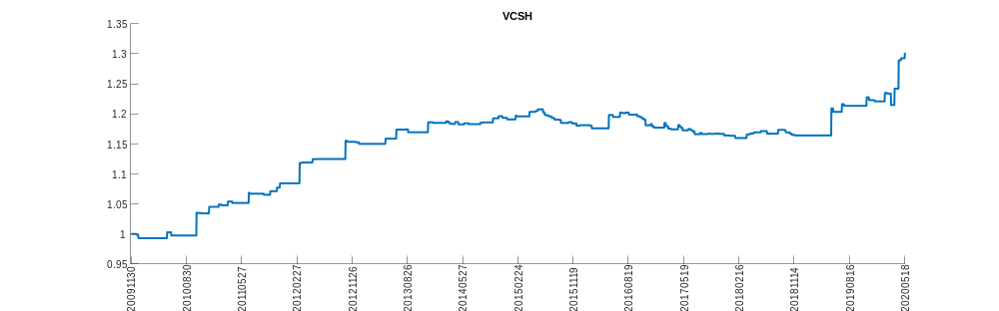
VTSS
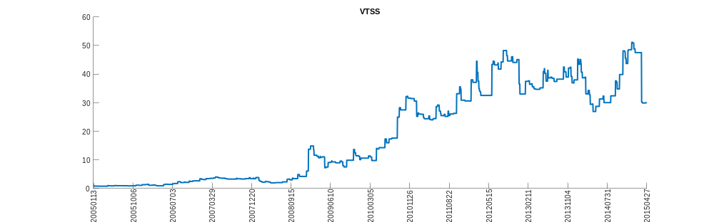
WFM
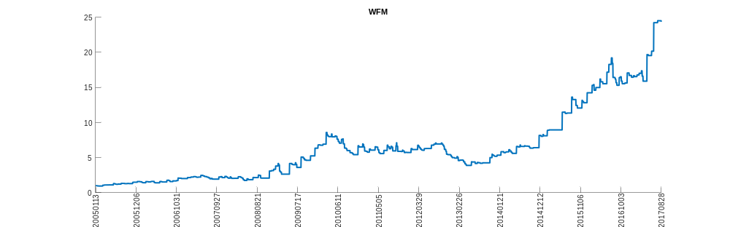
WILC
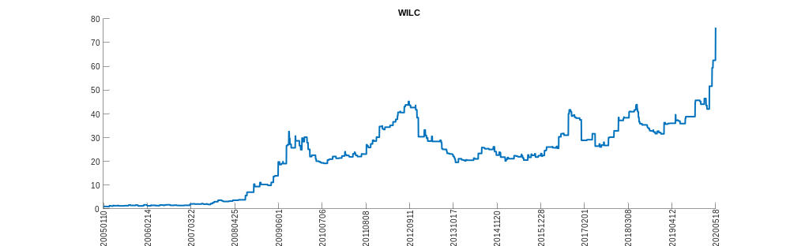
WLT
